Active Lives
Children and Young People

Year 3-6

Questionnaire Summary 2022-23

Introduction
This document has been designed to summarise the content of the Active Lives Children and Young People questionnaire for children in Years 3 to 6. Please note that the online questionnaire has been designed to be engaging for children to complete and therefore questions are not displayed in the same format as shown below.
Background information is highlighted in blue italic text for your information. This is not displayed to children.
Some questions will be displayed only to children in Year 5 and 6 classes. These are shown in red text.

Homepage
On entering the URL, Year 3 to 6 children will see the following screen.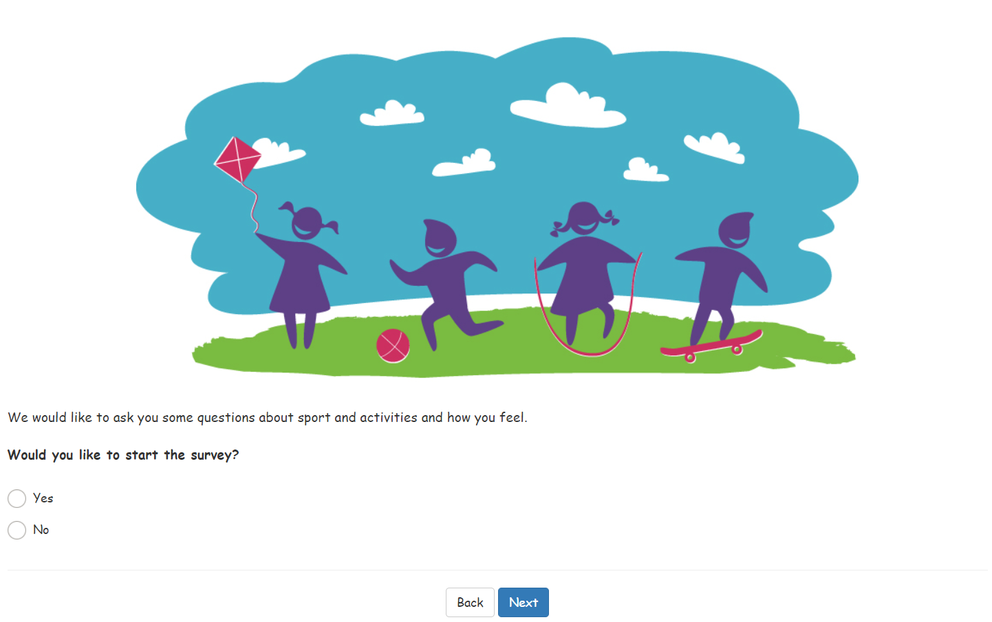

If respond ‘No’ to opening question
You can choose whether or not to take part. You have chosen not to start the survey. If you answered no by mistake click ‘back’ to go back to the previous question and start the survey now. If you would like to take part later you can go to the URL and start again when you want to. If you do not want to take part please select next and the survey will end.

Question 1

Where are you doing this survey?
- At school
- At home
- Somewhere else
- Prefer not to say

Question 2

Which school year are you in?
- Year 3
- Year 4
- Year 5
- Year 6

Question 3
Year 5 and 6 only – if Year 3 and 4 pupils are shown this question, they may have answered Question 2 incorrectly.

Since [current month] last year, have you been to see any live sporting events?
Please include all matches, races and competitions, including professional sport and watching friends and family compete.
X Please do not include any events that you took part in yourself, or events you watched on TV.
- Yes
- No
- Can’t remember

Question 4
Year 5 and 6 only. Asked if ‘Yes’ was selected at Question 3.

How many live sporting events have you been to see since [current month] last year?
Please include all matches, races and competitions, including professional sport and watching friends and family compete.
X Please do not include any events that you took part in yourself, or events you watched on TV.
- One
- Two
- Three or more

Question 5
Children should be encouraged only to think about the last week for this question. Some children might be tempted to select everything they have ever done but this would be incorrect and may also make subsequent questions more complex for them to answer.

Which of these have you done in the last seven days, since last [current day of the week]?
Please choose all the exercise, sport and fitness activities you did including online or TV led activities, e.g. online PE.
Include things like running around, dancing, walking and cycling as well as sports.
Include things you did at school (including in PE lessons), at home, at clubs, or somewhere else.

Please choose everything you did
Make sure you scroll down the screen so you see all of the activities
- Walking to get to school or other places such as friends’ houses or a park
- Going on a walk (includes walking a dog or hiking)
- Riding a scooter for fun or to get to places like school, friends’ houses or a park
- Cycling to get to school or other places such as friends’ houses or a park
- Cycling/riding a bike for fun or fitness (includes BMX or mountain biking)
- Dancing (including online or TV led e.g. TikTok dances, ballet, tap, street etc)
- Kicking a ball about
- Skateboarding, roller skating/blading
- Trampolining (including in a garden, at a trampoline centre, or as part of a club)
- Frisbee, throwing and catching (including piggy in the middle) or skipping
- Playing it, tag, chase, sardines or other running games
- Climbing or swinging in the playground, garden or park
- Swimming
- Gym or fitness (fitness/online class e.g. push-ups, sit-ups, or yoga, or using exercise machines e.g. rowing machine, exercise bike, running machine)
- Football
- Netball
- Hockey
- Cricket
- Rugby (including tag rugby)
- Baseball, softball
- Rounders
- Basketball
- Dodgeball, benchball
- Table tennis/ping pong
- Badminton
- Tennis
- Gymnastics
- Acrobatics including aerial, aerial hoop and acro
- Cheerleading
- Running, jogging, cross-country
- The daily mile, active mile, or other regular run done with your class at school
- Sports day events
- Horse riding
- Judo, karate, taekwondo and other martial arts
- Boxing
- Climbing (including indoors)
- Ice skating
- Water sports (canoeing, kayaking, sailing, rowing, surfing)
- If you did any other sports or exercise, please tell us what you did in the boxes below
- __________________
- __________________
- __________________
- __________________
- None of these

Question 6
Children who selected at least one activity at Question 5 are now shown a grid with the activities they selected on the left-hand side and school weekdays across the top. For example:
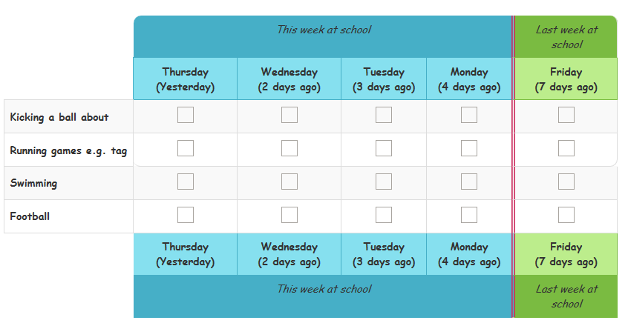
If children select a large number of activities, they may see separate grids showing groups of activities.

Please tell us on which days you did each of these activities while you were at school, during normal school hours.
Include activities in PE lessons and breaktimes
X Do not include activities at before and after school clubs, even if these took place at school
If you did not do one of the activities at school, during normal school hours, in the last seven days, just leave the row blank.
We will ask you about what you did outside usual school hours in the next question.
If you are completing this on a mobile or tablet, please scroll across to see all weekdays and enter your answers.

Question 7
Children who selected at least one activity at Question 5 are now shown a second grid with the activities they selected on the left-hand side and all seven days of the week across the top. For example:
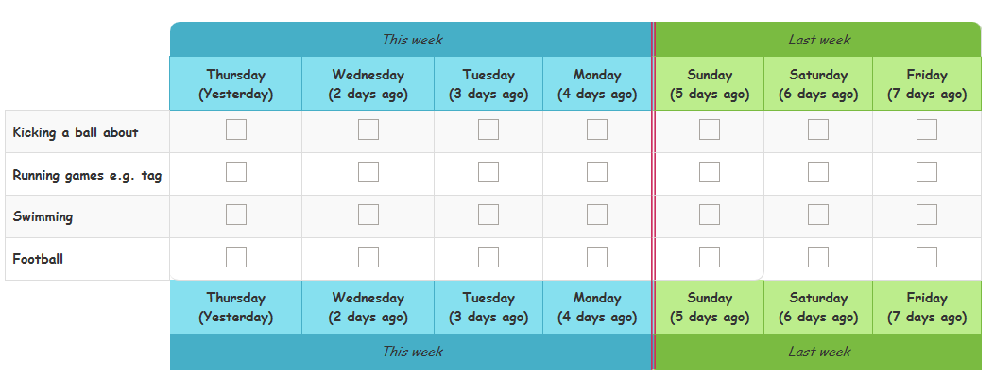

Now please tell us on which days you did these activities outside school hours.
Include activities you did:
- Before you got to school and after you left school
- At the weekend
- On holiday days
- At before and after school clubs, even if these took place at school
If you did not do one of the activities outside school hours in the last seven days, just leave the row blank.
If you are completing this on a mobile or tablet, please scroll across to see all weekdays and enter your answers.

Question 8
Children who say that they did any activities (excluding walking to or from school, or cycling to or from school) outside school hours, will be asked this question once for each activity.

You told us that on [day of the week], [X days ago], you [activity] outside normal school hours.

How long did you [activity] for?
As an example, if a child fills in the grid to show they played rugby on Friday, seven days ago, this question will ask ‘You told us that on Friday, 7 days ago, you played rugby outside normal school hours. How long did you play rugby for?”
- Less than 10 minutes
- About quarter of an hour
- About half an hour
- About three-quarters of an hour
- One hour
- More than an hour
- Don’t know

Question 9
Year 5 and 6 only.

And did you do [activity], indoors or outdoors?
- Indoors
- Outdoors
The indoors / outdoors questions will not be asked in relation to:
- Walking to get to school or other places
- Going on a walk
- Riding a scooter
- Cycling to get to school or other places
- Climbing or swinging in the playground, garden or park
- Cycling for fun
- Sports day
- Field athletics
- Rounders
- Dancing
- Kicking a ball about
- Swimming
- Football
- Hockey
- Rugby
- Running/jogging
- Gym or fitness
- Horse riding
- Martial arts
- Boxing

Question 10
Children who said that they walked to or from school on any day will be asked this question.

How long does it usually take you to walk to / from school?
- Less than 10 minutes
- About quarter of an hour
- About half an hour
- About three-quarters of an hour
- One hour
- More than an hour
- Don’t know

Question 11
Children who said that they cycled to or from school on any day will be asked this question.

How long does it usually take you to cycle to / from school?
- Less than 10 minutes
- About quarter of an hour
- About half an hour
- About three-quarters of an hour
- One hour
- More than an hour
- Don’t know

Questions 12 & 13
Children who selected at least one activity at Question 5 and gave a time slot in the grid will be asked the following questions for each activity they selected. Both questions appear on the same screen.
Some activities will have the intensity assumed and therefore these questions will not be asked.

When you [activity], did it make you breathe faster than sitting down reading?
- Yes
- No

When you [activity], did it make you hot or tired?
- Yes
- No

Question 14

How did you get to school today? Please choose all the ways you came to school today.
If did not select ‘At school’ in Question 1.
If today is not a school day, please select how you got to school last time.
- Walked
- Rode a bike
- Scooter
- Car or van
- Bus
- Train or tram or tube
- I did not go into school as I was learning from home
- None of these, please type in how you came to school

Questions 15 to 18
These questions are asked to all children and appear on the same screen. Children should be encouraged to think about all types of physical activity rather than a specific sport or type of exercise when answering these questions.

We would now like you to think about all types of exercise and sport.

How much do you agree or disagree with the following statements?

I enjoy taking part in exercise and sports.
- Strongly agree
- Agree
- Disagree
- Strongly disagree
- Can’t say

I feel confident when I exercise and play sports.
- Strongly agree
- Agree
- Disagree
- Strongly disagree
- Can’t say

I find exercise and sports easy.
- Strongly agree
- Agree
- Disagree
- Strongly disagree
- Can’t say

I understand why exercise and sports are good for me.
- Strongly agree
- Agree
- Disagree
- Strongly disagree
- Can’t say

Question 20

How much do you agree or disagree with the following statement?

I exercise because someone tells me I have to.
- Strongly agree
- Agree
- Disagree
- Strongly disagree
- Can’t say

Question 21

In the future would you like to do more, the same amount, or less exercise and sport than you do at the moment?

I want to do…
- More
- The same amount
- Less

Question 22
Asked if responded ‘More’ to Question 21

Thinking about doing more exercise or sport in the future, which statements apply to you?

Select all that apply
- I want to do more of the exercise and sports I do now
- I want to do different or new exercise or sports
- I don’t mind whether I do more of the same or do different exercise or sports
- Don’t know
- Prefer not to say

Question 23

Can you swim?
- Yes
- No

Question 24
Asked if pupil answered ‘Yes’ to Question 23.

Can you swim a length of a swimming pool (25 metres) without stopping?
- Yes
- No

Question 25

Can you stay in one place in the pool and keep your head above the water without holding onto the side or a float, and without touching the bottom of the pool? This is sometimes called treading water.
- Yes
- No

Question 26

Would you like to swim more often?
- Yes
- No

Question 27

Imagine that you fall into a large lake. The lake is deep and you can’t touch the bottom. You have all your clothes on, and you are about five metres away from the land (this is about the length of a large car). Could you get back to the land without someone helping you?
- Yes
- No

Question 28
Year 5-6 only

Can you ride a bike?
- Yes, without stabilisers
- Yes, with stabilisers
- Yes, an adaptive bike or adaptive trike for children with disabilities or special needs
- No
- Don’t know

Question 29
Year 5-6 only

Since [current month] last year, have you volunteered, or given your time to do any of the following activities?

Think only about when you do them to help with sports, exercise or dance.
Please choose everything you have done
- Raised money for sports or dance at school or a club
- Been a ‘sports leader’ or ‘sports ambassador’
- Helped with setting up or clearing away
- Helped with refreshments (food or drink)
- Given any other help. Please tell us what you did:
__________________
- No, have not done any of these activities since [current month] last year

Question 30
Year 5-6 only. Asked if one or more volunteering activity was selected at Question 29.
If just one activity was selected at Question 29:

And have you [activity from Question 29] more than once since [current month] last year?
If more than one activity was selected at Question 29:

Think about all those sport, dance and fitness activities you have given your time to support. Have you given your time more than once since [current month] last year?
- Yes
- No

Question 31

Overall, how happy did you feel yesterday?
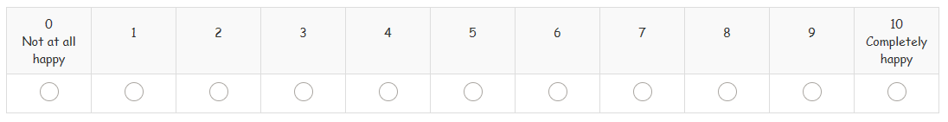

Question 32

Is this how you usually feel?
- Yes
- No

Question 33
For this question children should be encouraged to think about all activities, not just sport and physical activity. Icons are shown to help illustrate this.
Thinking about all the things you do at school and at home, how much do you agree or disagree with the following statement:

If I find something difficult, I keep trying until I can do it.
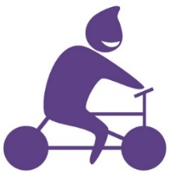
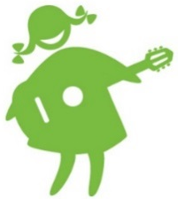
- Strongly agree
- Agree
- Disagree
- Strongly disagree
- Can’t say

Question 34

How much do you feel you can trust people who are a similar age to you?
- I can trust them a lot
- I can trust them a bit
- I can’t trust them very much
- I can’t trust them at all
- Can’t say

Question 35
We now have some final questions about you.

Are you a…
- Girl
- Boy
- Other
- Prefer not to say

Question 36

How old are you?
- 7
- 8
- 9
- 10
- 11

Question 37

Which one of these best describes your background or race?
- White (British or English)
- White (not British or English)
- Mixed race
- Asian or British Asian
- Black or Black British
- Other
- Prefer not to say

Question 38

Do you have a disability, special need or illness (e.g. autism, dyslexia, or asthma), which makes it difficult for you to do any of these things?
- Yes
- No
- Don’t know
- Prefer not to say

- Concentrating and paying attention (includes ADHD)
- How you behave in a way which makes life difficult (includes anger problems)
- Reading or writing (includes dyslexia)
- Using numbers (e.g. putting numbers the wrong way around)
- Difficulty learning or understanding new things (includes finding it hard to remember things)
- How you feel (including feeling anxious or depressed)
- Co-ordination (includes balance problems
- Moving around including walking and running
- Using your hands for writing or to pick things up (includes difficulty holding a pen)
- Seeing and using your eyes (includes colour blindness)
- Hearing and using your ears
- Speaking and communicating
- Breathing (includes asthma)
- Gives you pain (e.g. hypermobility)
- Affects your health for a long time (includes conditions such as diabetes)
- Something else you have difficulty with because of your disability, special need or illness

Question 39
Asked if answered ‘Yes’ to Question 38.

Which of these do you have difficulty with because of your disability, special need or illness?
Please tick all the boxes that apply
- Concentrating and paying attention (includes ADHD)
- How you behave in a way which makes life difficult (includes anger problems)
- Reading or writing (includes dyslexia)
- Using numbers (e.g. putting numbers the wrong way around)
- Difficulty learning or understanding new things (includes finding it hard to remember things)
- How you feel (including feeling anxious or depressed)
- Co-ordination (includes balance problems
- Moving around including walking and running
- Using your hands for writing or to pick things up (includes difficulty holding a pen)
- Seeing and using your eyes (includes colour blindness)
- Hearing and using your ears
- Speaking and communicating
- Breathing (includes asthma)
- Gives you pain (e.g. hypermobility)
- Affects your health for a long time (includes conditions such as diabetes)
- Something else you have difficulty with because of your disability, special need or illness
- None of these
- Don’t know
- Prefer not to say

Question 40
Asked if answered any response bar ‘None of these, ‘Don’t know’ or ‘Prefer not to say’ to Question 39.

Does this disability, special need or illness have a big effect on your life?
- Yes
- No
- Don’t know
- Prefer not to say

Question 41
Asked if answered any response bar ‘None of these, ‘Don’t know’ or ‘Prefer not to say’ to Question 39.

Do you think this disability, special need or illness will last for a year or more?
- Yes
- No
- Don’t know
- Prefer not to say

Question 42
If a child spends their time living in different homes with different parents or carers, they should answer these questions thinking about the home they will stay at tonight.
We would now like to ask you some questions to understand more about your home and your family.
These questions will help us find out more about what affects how much sport and exercise children and young people do.

Does your family own a car, van or truck?
- No
- Yes, one
- Yes, two or more
- Prefer not to say

Question 43

Do you have your own bedroom for yourself?
- Yes
- No
- Prefer not to say

Question 44

How many computers does your family own (including laptops and tablets/iPads, but NOT including game consoles and smartphones)?
- None
- One
- Two
- More than two
- Prefer not to say

Question 45

How many times did you and your family travel out of England for a holiday last year?
- None
- Once
- Twice
- More than twice
- Prefer not to say

Question 46

How many bathrooms are in your home?
- None
- One
- Two
- More than two
- Prefer not to say

Question 47

Does your family have a dishwasher at home?
- Yes
- No
- Prefer not to say

Final screen
Pupils’ answers are automatically submitted. Once they reach this screen they can close the browser.

Thank you! That is the end of the survey.
If you have questions or are worried about anything in the survey, or anything else in your life the first person to talk to is a parent, other family member or someone else you trust, if you feel able to.
If you want more information or someone else to talk to there are some ideas below.
It is absolutely fine if you don’t need or want to talk to someone – we are providing this to everyone who takes part. None of the organisations listed will know that you took part in the survey, nor will they get in touch with you.
NHS: www.nhs.uk
This site helps you make choices about your health, exercise and healthy eating and has information on finding and using NHS services.
For advice and information on being physically active please visit: https://www.nhs.uk/live-well/exercise/physical-activity-guidelines-children-and-young-people/
CHILDLINE: 0800 11 11
A confidential and free helpline which will not appear on a phone bill. You can also go online for a 1-2-1 instant messenger chat with someone who is there to listen and support you at: www.childline.org.uk

